Customer

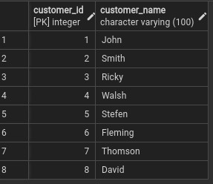

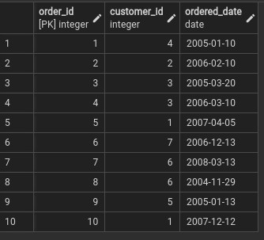Product

Orders 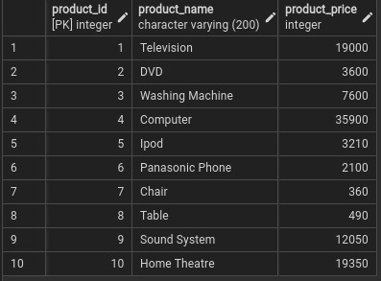

Order_Details

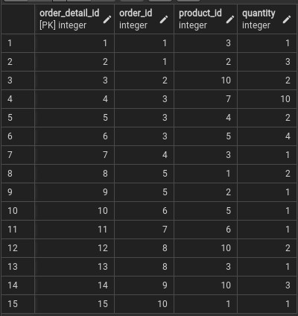

1. Fetch **all the** Customer Details along with the product names that the customer has ordered.
2. Fetch Order_Id, Ordered_Date, Total Price of the order (product price*qty).
3. Fetch the Customer Name, who has not placed any order
4. Fetch the Product Details without any order(purchase)
5. Fetch the Customer name along with the total Purchase Amount
6. Fetch the Customer details, who has placed the first and last order
7. Fetch the customer details , who has placed more number of orders
8. Fetch the customer details, who has placed multiple orders in the same year
9. Fetch the name of the month, in which more number of orders has been placed
10. Fetch the maximum priced **Ordered Product**

Answers

1. Fetch all the Customer Details along with the product names that the customer has ordered.

SELECT Customer.*, Product.Product_name FROM Order_Details

LEFT JOIN Orders

ON Order_Details.Order_id = Orders.Order_id

LEFT JOIN Product

ON Order_Details.Product_id = Product.Product_id

LEFT JOIN Customer

ON Orders.Customer_id = Customer.Customer_id

ORDER BY Customer_Id ;

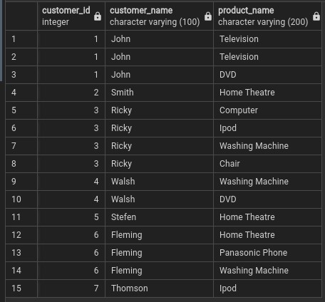

1. Fetch Order_Id, Ordered_Date, Total Price of the order (product price*qty)

SELECT Orders.Order_id,

Orders.Ordered_date,

(Product.Product_price*Order_details.quantity) AS TOTAL

FROM Order_Details

LEFT JOIN Orders ON

Order_details.Order_id = Orders.Order_id

LEFT JOIN Product ON

Order_details.Product_id = Product.Product_Id ;

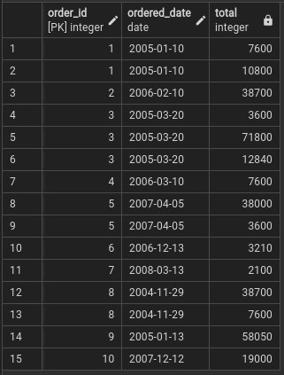

1. Fetch the Customer Name, who has not placed any order

SELECT Customer.Customer_name From Order_details

LEFT JOIN Orders

ON Order_Details.Order_id = Orders.Order_id

FULL OUTER JOIN Customer

ON Orders.Customer_Id = Customer.Customer_id

WHERE Customer.Customer_id

NOT IN (SELECT Customer_id FROM Orders);



1. Fetch the Product Details without any order(purchase)

SELECT Product.* FROM Product

LEFT OUTER JOIN Order_details

ON Product.Product_id = Order_Details.Product_id

WHERE Product.Product_id NOT IN(

SELECT Product_id FROM Order_details);

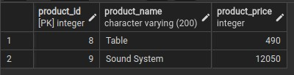

1. Fetch the Customer name along with the total Purchase Amount

SELECT Customer.Customer_Name, SUM(Product.Product_Price) FROM

Order_details

INNER JOIN Orders ON Order_details.Order_id = Orders.Order_id

INNER JOIN Product ON Order_details.Product_id = Product.Product_id

INNER JOIN Customer ON Orders.Customer_id = Customer.Customer_id

GROUP BY Customer.Customer_Name ;

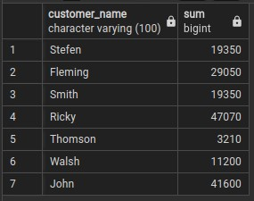

1. Fetch the Customer details, who has placed the first and last order

SELECT Customer.*, Orders.Ordered_date FROM Order_details

INNER JOIN Orders ON Order_details.Order_id = Orders.Order_id

INNER JOIN Customer ON Orders.Customer_id = Customer.Customer_id

WHERE Orders.Ordered_Date = (SELECT MAX(Orders.Ordered_date)FROM

Orders) OR

Orders.Ordered_date = (SELECT MIN(Orders.Ordered_date) FROM Orders)

LIMIT 2;

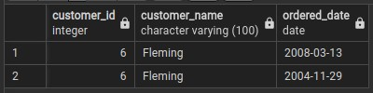

1. Fetch the customer details , who has placed more number of orders

SELECT Customer.*, COUNT(*) AS TIMES FROM Orders

LEFT JOIN Customer ON Orders.Customer_id = Customer.Customer_id

GROUP BY Customer.Customer_ID

Order BY TIMES DESC ;

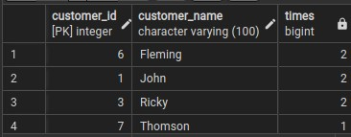

1. Fetch the customer details, who has placed multiple orders in the same year

SELECT Customer.*, Count(*) AS Order_s, EXTRACT(YEAR FROM

Orders.Ordered_Date) AS Years FROM Orders

INNER JOIN Customer ON Orders.Customer_id = Customer.Customer_id

Group By Years, Customer.Customer_id

Order by order_s DESC

LIMIT 1;

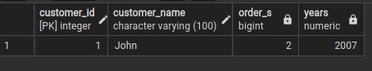

1. Fetch the name of the month, in which more number of orders has been placed

SELECT Count(*) as Orders, to_char(Ordered_date, 'Month') as mont_h

FROM Orders

Group By Mont_h

Order by orders DESC

LIMIT 1;

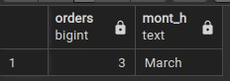

1. Fetch the maximum priced Ordered Product

SELECT Product.Product_name, Product.Product_Price

FROM Product

RIGHT JOIN Order_Details ON Product.Product_id =

Order_Details.Product_id

GROUP by Product.Product_name, Product.Product_Price

ORDER BY Product_Price DESC

LIMIT 1;

